I. Links

* Github: <https://github.com/HaydenDuong/SIT305-Mobile_Application_Development/tree/main/Task%205.1C>
* Panopto (Video Demo): <https://deakin.au.panopto.com/Panopto/Pages/Viewer.aspx?id=fabaf229-41f5-42a7-acbd-b2d000415d88>

II. Screenshots

A / Subtask 1 – News App

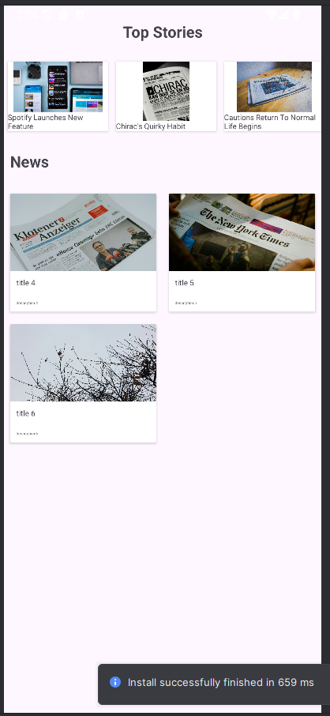

Figure 1 – Main Fragment

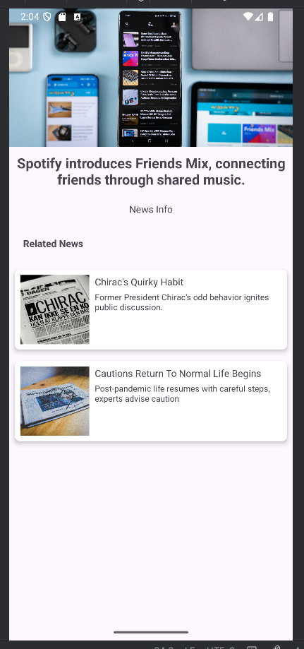

Figure 2 – News Detail Activity (housed in Main Fragment)

B/ Subtask 2 – Itube App

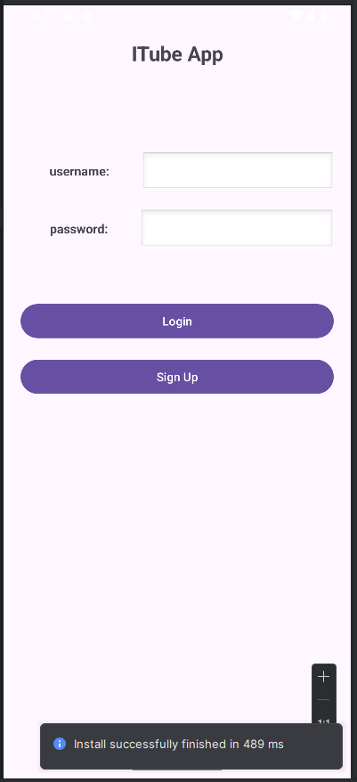

Figure 3 – Login Activity

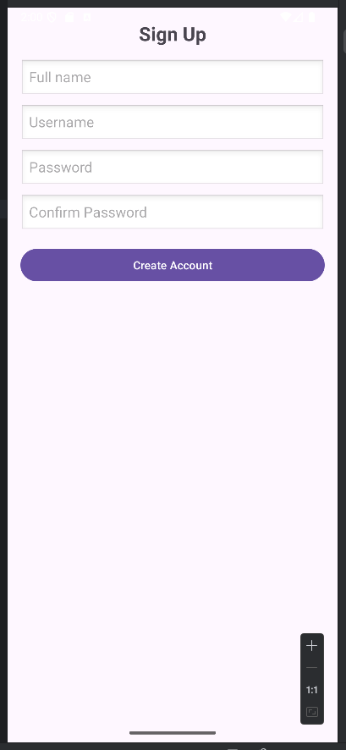

Figure 4 – Sign Up Fragment (housed in Login Acitivity)

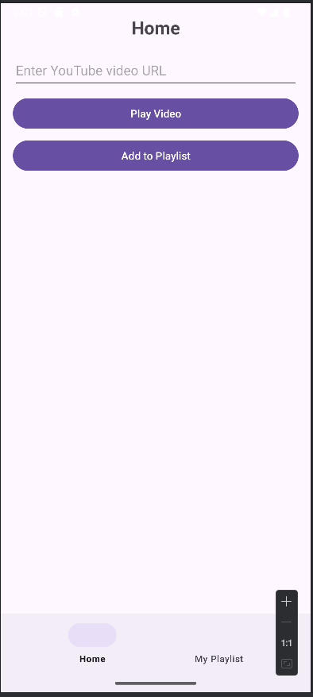

Figure 5 – Home Acitivity

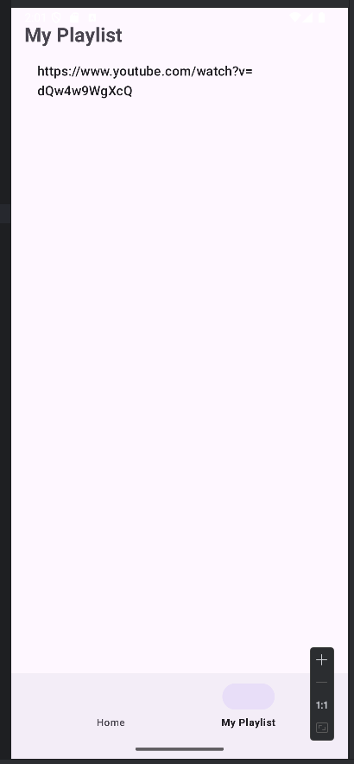

Figure 6 – My Playlist Fragment (housed in Home Activity)

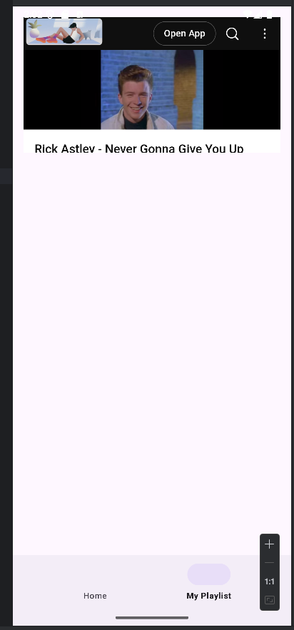

Figure 7 – Play Video Fragment (housed in Home Activity)